|  |
| --- |
| **15th International Symposium on Computer Science in Sport (IACSS 2025)** |

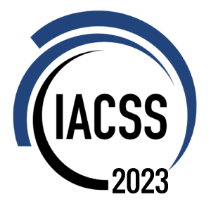Conference Registration Form

**Application instructions**

We look forward to receiving your application.

Make sure to submit this application form to organizer email [iacss.2025.tgu@gmail.com](mailto:iacss.2025.tgu@gmail.com)

*Note: The registration will be confirmed after registration fee being received in full (you can also submit payment proof for early confirmation) and registration form being submitted to the conference email address.*

Please complete the following form carefully. You will be required to complete all boxes marked with an asterisk (*).

All other boxes may be completed to provide additional details.

|  |  |
| --- | --- |
| Personal Details (*required) | |
|  | |
| *First Name |  |
| *Last Name |  |
| *Email |  |
| *Affiliation/  Organization |  |
| Institute/  Department |  |
| City |  |
| *Country / Region |  |
| Mobile |  |
| Social event | Please select if you want to participate: Conference Dinner 🞏 |
| Special dietary | Diabetic 🞏 Vegetarian 🞏 Halal Food 🞏 Other 🞏  Please specify |
| Special requirements (if any) |  |

**Registration Fee Information**

**Participant**

The following services are included in the registration fee:

* Access to all scientific sessions
* Access to commercial exhibition
* Access to poster exhibition
* Coffee breaks
* Right to participate in the excursions of the program
* Full conference material
* Invitation to Conference Dinner

**Accompanying person**

The following services are included in the registration fee:

* Invitation to the Welcome Reception
* Invitation to the conference dinner

Please choose the type of participant you want to register as:

|  |  |  |  |
| --- | --- | --- | --- |
| Registration Fee (by Japanese Yen) * | | | |
|  | | |  |
|  | Early Bird (Ends 30th June) | Standard Fee |  |
| Full – Non-member | 40,000 | 45,000 | 🞏 |
| Full – Member | 35,000 | 40,000 | 🞏 |
| Student – Non-member | 20,000 | 25,000 | 🞏 |
| Student – Member | 15,000 | 20,000 | 🞏 |
| Exhibitors | 50,000 | 70,000 | 🞏 |
| Accompanying Person | 15,000 | 20,000 | 🞏 |

*\*Early-bird registration ends 30.06 2023*

**Payment Information**

The payment of the registration fee will be done by PayPal. The payment information can refer to [website registration page](https://iacssconference.org/#/2025/registration)

IACSS 2025 Organizing Committee